

RPA PROJECT

Deployment Guide on UIPATH

MIGS SETTLEMENT PROCESS

Table of Contents

1. INTRODUCTION
   1. Purpose
   2. Document Control
   3. Revision History
   4. Intended Audience
   5. Definitions/Acronyms
2. SERVER CONFIGURATIONS
   1. UIPATH System Architecture
3. DEPLOYMENT PROCEDURE
   1. Pre-requisites
   2. Deployment Procedure
4. SANITY TESTING AND TROUBLE SHOOTING
5. Sanity Testing & Trouble shooting
   1. Performing Sanity Tests
   2. Troubleshooting Issues

1. INTRODUCTION

The Migs visa settlement process download report from the file server portal. Do some filtering and data manipulation then build an upload file. The bot sends the report generated via mail to the supervisor. The Bot also detect if the account is balanced or not.

1.1 Purpose

The RPA solution will be expected to eliminate a lot of the manual processes involved downloading report and preforming some calculations and finally building an upload file as an output document

1.2 Document Control

Change History

|  |  |  |  |
| --- | --- | --- | --- |
| Version Number | Version date | Description of changes | Author |
| 1.0 |  |  | Bakare Sodiq |
| 1.3 Review History |  |  |  |
| Version Number | Version date | Review Comments | Reviewer |
| 1.0 |  |  |  |

1.4 Intended Audience

This document is intended for the operations team to enable them perform deployment activities on the UIPATH Orchestrator.

* 1. Definitions and Acronyms

*studio:* The platform on which the automation is performed. The process is developed here.

*Orchestrator:* is a web application that enables you manage the creation, monitoring, and deployment of resources in your environment.

*. Xaml :* The format in which files are being saved on UI Path

*query:* Used to perform Database interaction

*Bot Controller:* An individual that mans the working operation of the bot.

1. SEVICES CONFIGURATION UIPATH

Before deploying the process, a work folder must be created. This folder is used by bot for its operations. Please follow the step below.

1. A folder name “_BotWorkDirectories” should be created in the document directory
2. A folder name “MIGS_WorkDirectories” should be created in folder created in step I
3. Inside of the folders Two folder should be created
   1. “ExternalConfigFiles”
   2. WorkFolders
4. Please Request for an Excel file from the developer if not provided
5. The Excel file should be copy inside of the folder (ExternalConfigFiles) a created in step ii
6. Ensure step I to iv is done correctly
7. Navigate to orchestrator instance that the bot will be deploy to (Cloud.uipath.com)
8. Select the workspace to be use by the bot
9. Navigate to Assets
10. Please create the following assets

|  |  |
| --- | --- |
| **Assets** | **Value** |
| RobotEmailAddress | Email provision on the Server |
| ErrorEmailTo | Email the bot to report to |
| ErrorEmailCc | Email the bot to report to cc |
| ReportEmailTo | Email the bot to report Error to |
| ReportEmailCc | Email the bot to report Error to cc |
| OutLookCredential | The Outlook Credential |
| VISA_MIGSSettlement_ArchiveFolderPath | Full path eg;  …..\Documents\_BotWorkDirectories\  MIGS_WorkDirectories\WorkFolders\Archive |
| VISA_MIGSSettlement_ExceptionFolderPath | Full path eg;  …..\Documents\_BotWorkDirectories\  MIGS_WorkDirectories\WorkFolders\Exception |
| VISA_MIGSSettlement_ProcessingFolderPath | Full path eg;  …..\Documents\_BotWorkDirectories\  MIGS_WorkDirectories\WorkFolders\Processing |
| VISA_MIGSSettlement_ProcessDataConfigFilePath | Full path of the excel copied in step VI |
| UPSL_FTP_URL | The Ftp url server |
| VISA_DownloadFolderPath | Full path of the Download Folder |
| Visa_AddDays | -1 |
| FTPCredential | Credential of the File Server FTP |

|  |  |
| --- | --- |
|  |  |
|  |  |
|  |  |
|  |  |
|  |  |
|  |  |
|  |  |
|  |  |
|  |  |
|  |  |

1. APPLICATION ARCHITECTURE

1. DEPLOYMENT ACTIVITIES
   1. Publish to UiPath Orchestrator
   2. Confirm Dependencies and Database
   3. Run process from Orchestrator
2. PRE-REQUISITES DEPLOYEMENT

For any process-related deployments the following would be shared by the developer.

1. List of assets and their values. Please refer to No 3
2. Please ensure that required server access is available prior to deployments.
3. DEPLOYMENT PROCEDURE

Method 1

* 1. Publish to Test Orchestrator
  2. Download the Nuget package
  3. Send Nuget Package for deployment
  4. Create process assets
  5. Import process package on production
  6. Create a process

Method 2

1. Bot controller Copies the Zipped process file sent via email, to the deployment server
2. Extract the zipped file
3. Open the main xaml file in Studio
4. Validate that there are no errors and all UiPath package dependencies are installed and updated
5. Publish on orchestrator

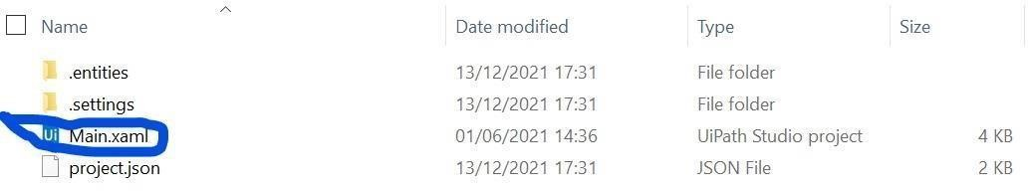

Fig. 3.1: Folder showing the xaml file

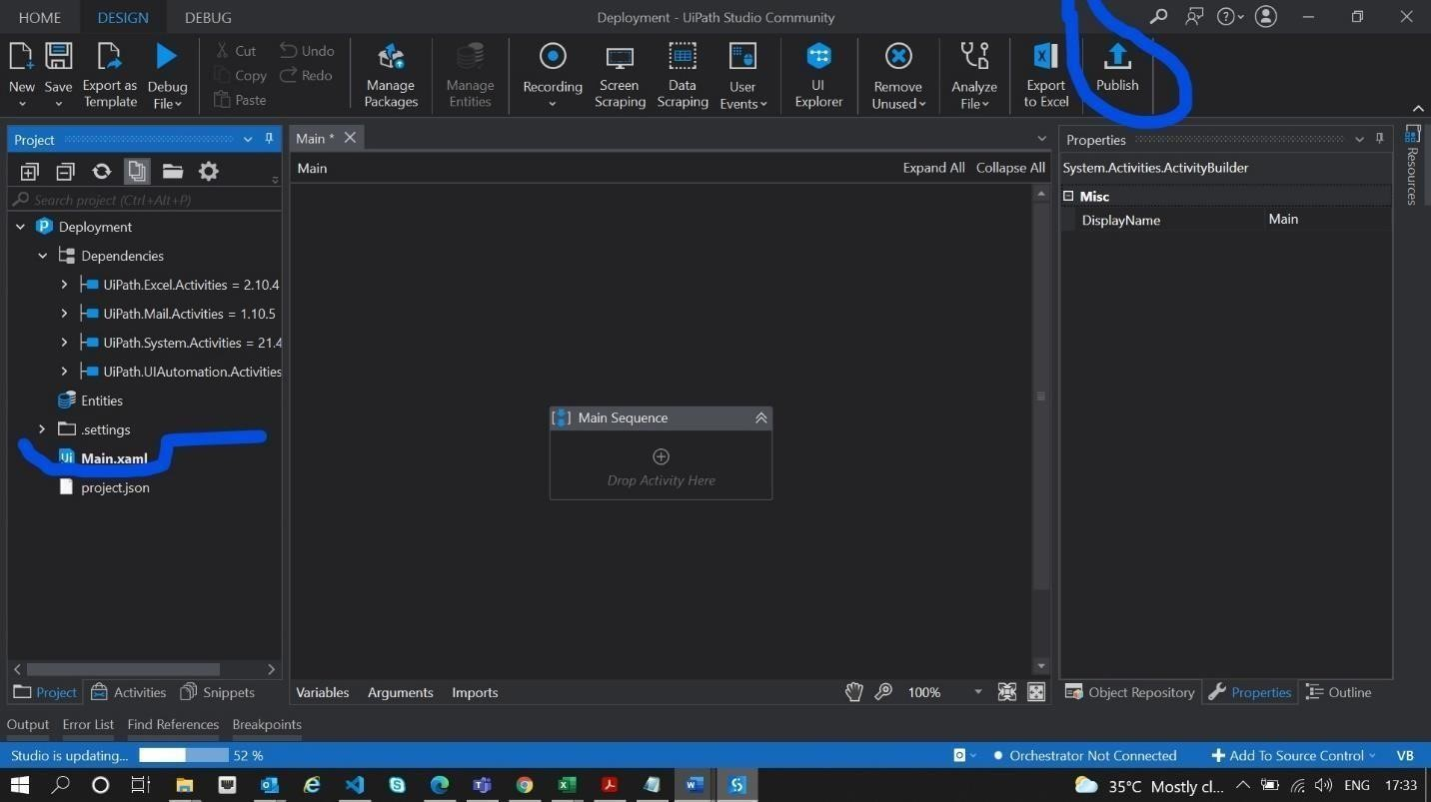

Fig. 3.1: UiPath Studio showing the project dependencies and Publish icon

|  |  |  |
| --- | --- | --- |
| S/No | Action | Responsibility |
| 1 | Login to Deployment Server and import the zipped project folder | IT Third Party |
| 2 | Extract the file and save to the directory of choice | IT Third Party |
| 3 | Open the xaml file on UI Path studio | IT Third Party |
| 4 | Validate that all process dependencies are correctly installed without errors | IT Third Party |
| 5. | Create all orchestrator assets needed for the deployment environment | IT Third Party |
| 6. | Run process from start to finish and ensure it runs as expected. | IT Third Party |
| 7. | Publish process to orchestrator. | IT Third Party |

1. SANITY TESTING AND TROUBLE SHOOTING

Performing Sanity Tests

* 1. After deployment, ensure that Database are accessible.
  2. After deployment, ensure that scheduled process time is not interfering with another.
  3. After deployment, ensure the process can run successfully on the orchestrator
  4. If changes are made on the config file after publishing, republish the file to update.

1. Troubleshooting after deployments

If there is an Issue while performing any of the steps above, kindly review the necessary logs and raise error messages with respective developer.

|  |  |  |  |
| --- | --- | --- | --- |
|  | Name | Signature | Date |
| Prepared By | Bakare Sodiq |  | 06/08/2022 |
| Reviewed By |  |  |  |
| Approved By |  |  |  |